Mushroom Stroganoff
Inspired by


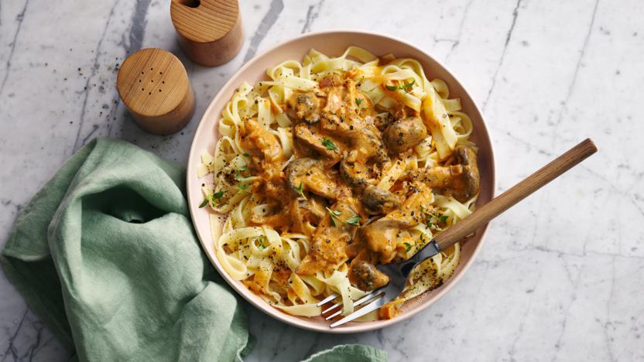
DID YOU KNOW?
“Mushrooms are a superfood that offer a variety of health benefits such as boosting the immune system. So go on, be the fungi and add those mushrooms to your meals today!”

Nutrition – Total / Per Serving
Calories: 1200kcal / 600kcal
Carbohydrates: 173g / 86.5g
Protein: 32g / 16g
Fat: 27g / 13.5g
Fibre: 11g / 5.5g
Sugar: 15g / 7.5g
Ingredients
200g of fusilli pasta
½ tbsp olive oil
½ tbsp butter
350g of mixed variety mushrooms
1 red onion
2 cloves of garlic
50ml whisky
½ tbsp plain flour
75ml vegetable stock
200ml coconut milk
½ tbsp Dijon mustard






Good for:

Star Rating:




Method



Step 1 - Preparation
Boil the kettle.
Slice the mushrooms and garlic.
Dice the onion.
Prepare the vegetable stock according to the packet instructions.

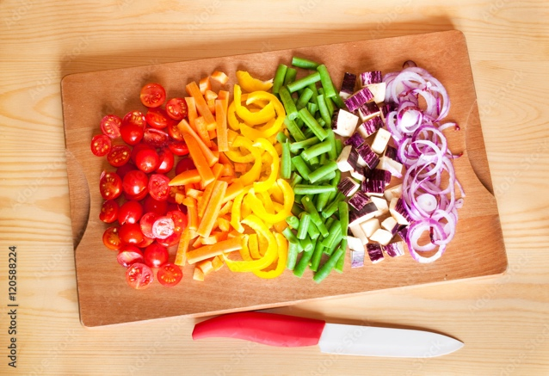
Step 2 – Pasta & Mushrooms
Cook the pasta according to the package instructions.
Heat the oil and butter in a frying pan.
Add the mushrooms with a pinch of salt and pepper.
Fry until golden.
Remove the mushrooms and place on a separate plate for later.
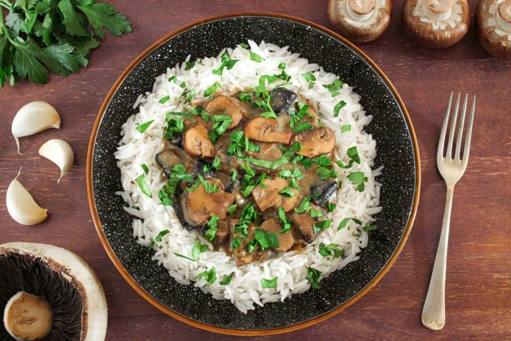
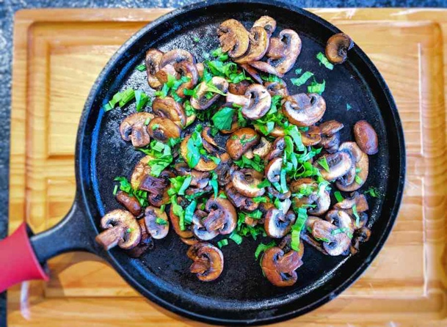
Step 3 – Fry it & Make it Saucy
Fry the onion until tender and slightly golden (~7 minutes).
Add the garlic and cook for a further 30 seconds.
Add the whisky to the frying pan and let it simmer until the liquid has reduced in half.
Add the flour, mix well until combined.
Pour in the vegetable stock and bring to the boil.
Add the mushrooms and mix to combine.
Add the coconut milk and mustard.
Mix and let simmer over low heat. (~10 minutes)
Step 4 – Bring it Together
Turn the heat off for the frying pan.
Season with salt and pepper.
Drain the pasta and add to the sauce.
Mix well and serve.

Enjoy!

